Project Title

# Description

A device which can monitor and switch household water pumps remotely.

# Constraints

Power: Mains voltage 100-240V

Dimensions: Must fit within a typical junction box, preferably a 10x10cm box

# Features

* Monitor the On/Off status and current consumption
* Switch the pump off if desired.
* Indicate if the pump is running dry.
* Wireless connectivity
* Matter optional

# Block Diagram

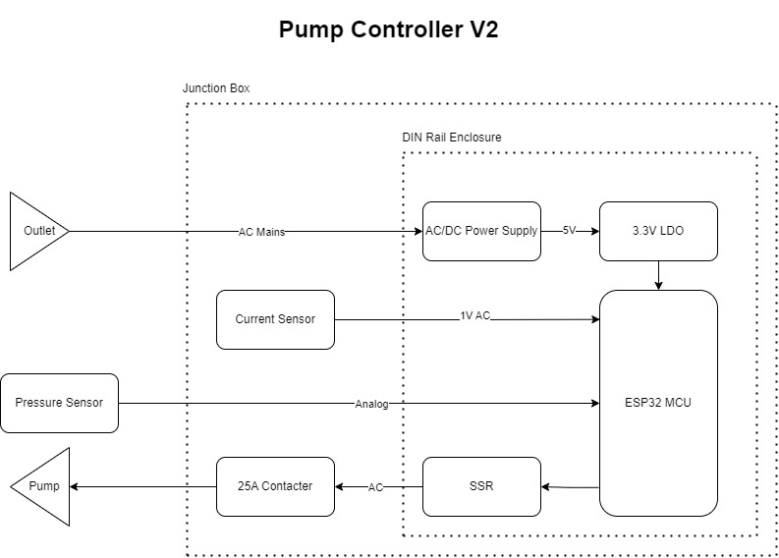

# Components

MCU: ESP32-C3-MINI-1U-H4

## AC/DC Power Supply: IRM-03-5

## 3.3V LDO: AP2112K-3.3TRG1

## Current Sensor: SCT013-30

Pressure Sensor: Seeed 114991178 or equivalent.

SSR: AQH2223AX

Contactor: Tomzn TOCT1-25 (Aliexpress)

Din Rail Enclosure: Szomk AK-DR-103, LK SHINY LK-DR56 or BUD IND DMB-4771

Box: Minimum 12x12cm

# Power Budget

|  |  |  |  |  |
| --- | --- | --- | --- | --- |
| Component | Voltage/s | Current/s | Power | Type |
| IRM-03-5 | 5V | 0.6A | 3W | Source |
| AP2112K-3.3TRG1 | 3.3V | 0.6A | 1.98 | Source |
| ESP32-C3-MINI-1U-H4 | 3.3V | 0.35A | 1.15W | Sink |
| 114991178 | 5 | 0.01 | 0.05W | Sink |
| AQH2223AX | 5 | 0.02 | 0.1W | Sink |
|  |  |  |  |  |
| Total | 1.3W | | |  |

*Some ICs have multiple voltage rails with different voltage levels.